

Case Study Assignment **(MKT 302)**

SCHOOL OF COMPUTER SCIENCE AND ENGINEERING

TEAM MEMBERS

**Submitted To**

**Dr. Vishwas Gupta** (Associate Professor @LPU)

**[Mittal School of Business]**

**PEER RATINGS:**

\****Alok kumar*** doesn’t intrested in our project. He didn’t do anything even we talked him for his participitation.

**INDEX TABLE**

|  |  |  |
| --- | --- | --- |
| S.No. | Topics | Page no. |
| 1. | INTRODUCTION | 4 |
| 2. | BRAND | 4 |
| 3. | COMPETITIORS | 6 |
| 4. | 4 P’S STRATEGIES | 7 |
| 5. | SEGMENTATION | 10 |
| 6. | SWOT ANALYSIS | 11 |
| 7. | THREATS | 13 |
| 8. | MOBILE MARKETING NETWORKS | 14 |
| 9. | MOBILE CHANNELS | 14 |
| 10. | CONCLUSION | 24 |
| 11. | REFERENCE | 25 |

**INTRODUCTION**

* **Tanishq** is a [jewellery](https://en.wikipedia.org/wiki/Jewellery) brand of [India](https://en.wikipedia.org/wiki/India). It is a division of [Titan Company](https://en.wikipedia.org/wiki/Titan_Company), a company promoted by the [Tata Group](https://en.wikipedia.org/wiki/Tata_Group) in collaboration with the [Tamil Nadu Industrial Development Corporation](https://en.wikipedia.org/wiki/Tamil_Nadu_Industrial_Development_Corporation) (TIDCO).Tanishq's headquarters is at [Bengaluru](https://en.wikipedia.org/wiki/Bengaluru) in [Karnataka](https://en.wikipedia.org/wiki/Karnataka).
* By the end of the 1980s, the Titan company launched Tanishq in an attempt to earn its own foreign exchange, focused largely on exports. In the early 1990s, India's exchange issue was fixed, and the Titan Company chose to focus the brand on the Indian market.
* The first production plant launched in August 1992, and Tanishq's first store opened in 1996.

**BRAND**

* Tanishq has emerged as India’s fastest growing jewellery brand and is a name which signifies superior craftsmanship, exclusive designs and superlative product quality.
* The term Tanishq was coined by Mr. Xerxes Desai by marrying the words **‘Tan’** meaning body and **‘Nishk’** meaning a gold ornament.
* Tanishq has brought to the market a whole new standard of business ethics and product reliability, in the process bringing about a transformation in which jewellery is bought or sold in India.
* Not only does it abide by the stringent standards but also adheres to strict and uniform guidelines across all 328 stores across 200 cities.
* It is also the only jeweller in India with a state-of-art factory in Hosur, Tamil Nadu and takes utmost care to ensure that it complies with labour laws and environmental standards. There are 3 other units in Dehradun, Pantnagar and Sikkim as well.
* With retail sales of over Rs. 18600 crores in the last financial year.
* Tanishq was the first jewellery retail brand in India.
* Tanishq made the beauty pageant crowns for the [Femina Miss India](https://en.wikipedia.org/wiki/Femina_Miss_India" \o "Femina Miss India) 2007.
* In May 2015, Tanishq enrolled [Deepika Padukone](https://en.wikipedia.org/wiki/Deepika_Padukone) to be the brand's ambassador.
* In 2017, Tanishq launched a sub-brand called Rivaah targeting the wedding segment.

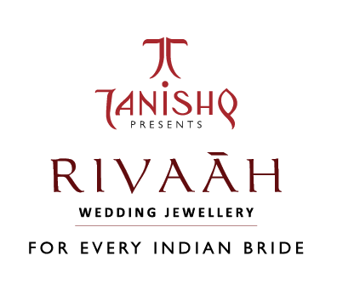

* In January 2017, the Titan group merged its *Gold Plus* stores with the larger Tanishq retail brand.
* In April 2017, Tanishq launched the sub-brand Mirayah to cater to women under their 40s.
* In December 2017, Tanishq launched the Aveer line, its first line of products for men.

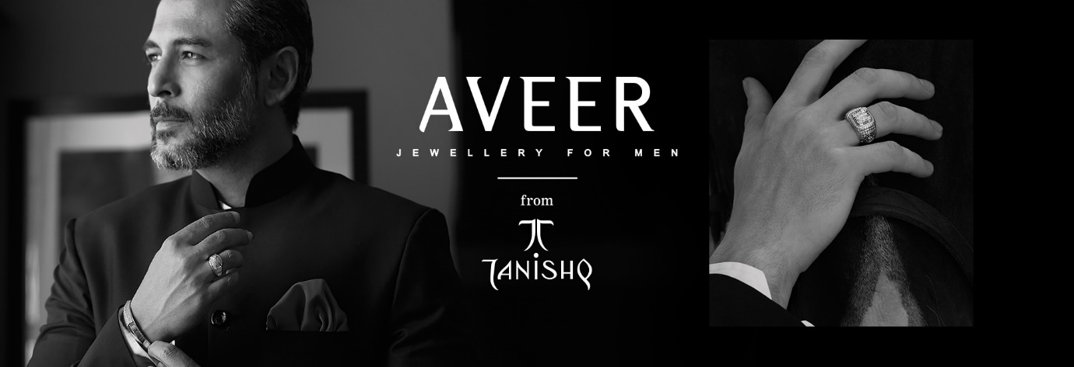

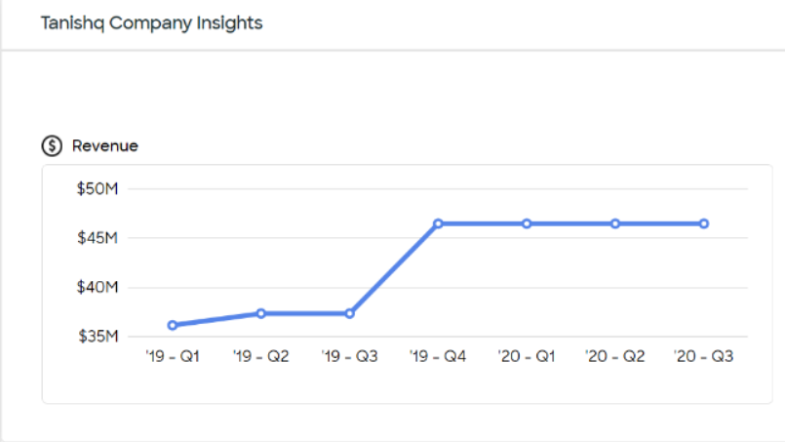

**Tanishq Competitors:**

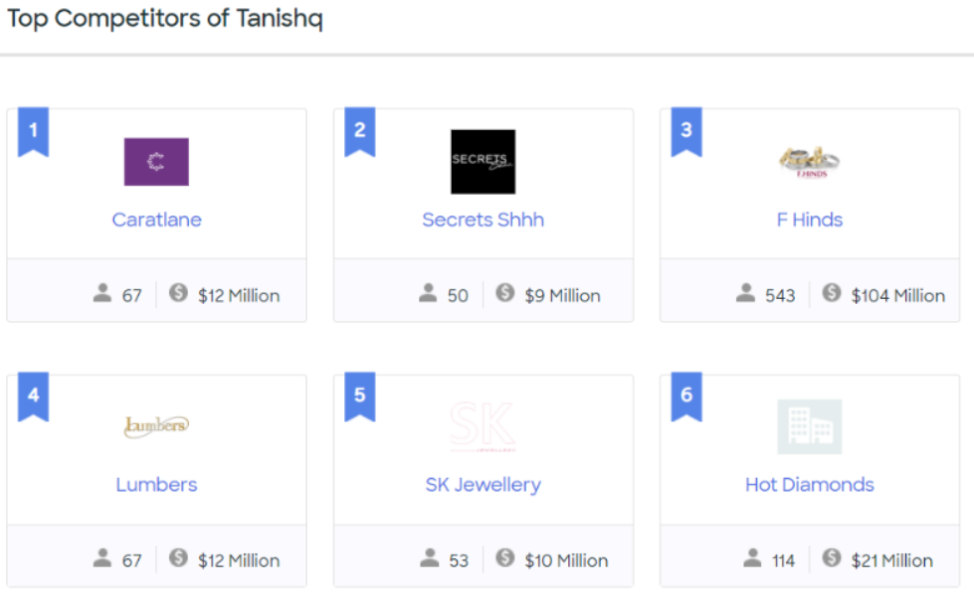

* [**De Beers**](https://www.mbaskool.com/brandguide/lifestyle-and-retail/2681-de-beers.html) **:** It is an international corporation that specialises in [diamond](https://en.wikipedia.org/wiki/Diamond_(gemstone)) exploitation, diamond mining, diamond retail, [diamond trading](https://en.wikipedia.org/wiki/Diamond_trading) and [industrial diamond](https://en.wikipedia.org/wiki/Industrial_diamond) manufacturing sectors. It operates in 35 countries and mining takes place in [Botswana](https://en.wikipedia.org/wiki/Botswana), [Namibia](https://en.wikipedia.org/wiki/Namibia), [South Africa](https://en.wikipedia.org/wiki/South_Africa), [Canada](https://en.wikipedia.org/wiki/Canada) and [Australia](https://en.wikipedia.org/wiki/Australia).
* [**Nakshatra**](https://www.mbaskool.com/brandguide/lifestyle-and-retail/3408-nakshatra.html) **:** Nakshatra Jewellery is the latest trendy diamond jewellery in the market. With a traditional name as such, traditional diamond jewellery is very common. Nakshatra Diamond Rings.
* [**Ddamas**](https://www.mbaskool.com/brandguide/lifestyle-and-retail/3022-ddamas.html) **:** Damas Jewellery is founded, the start of a remarkable legacy to offer goldsmith services in the Middle East.
* **TBZ :** Tribhovandas Bhimji Zaveri Ltd. (TBZ) is a noted [Indian](https://en.wikipedia.org/wiki/India) [jeweller](https://en.wikipedia.org/wiki/Jeweller) and jewellery retail chain based in India.[[2]](https://en.wikipedia.org/wiki/Tribhovandas_Bhimji_Zaveri#cite_note-2) Established in 1864 (156 years ago) by Tribhovandas Bhimji Zaveri in [Zaveri Bazaar](https://en.wikipedia.org/wiki/Zaveri_Bazaar), the jewellery district of [Mumbai](https://en.wikipedia.org/wiki/Mumbai),
* [**Reliance Jewels**](https://www.mbaskool.com/brandguide/lifestyle-and-retail/2877-reliance-jewels.html) **:** This is the retail unit of jewellery of reliance group founded in 2007.
* **P.C. Chandra Jewellers:** P.C. Chandra Jewellers began in 1939 and grew to be India's one of the largest jewellery house with a legacy of over eight decades.

**Tanishq iMarketing iMix iStrategy i(4Ps)**

Marketing iMix iof iTanishq ianalyses ithe ibrand iwhich icovers i4Ps i(Product, iPrice, iPlace, iPromotion) iand iexplains ithe iTanishq imarketing istrategy. iAs iof i2020, ithere iare iseveral imarketing istrategies ilike iproduct,service iinnovation, imarketing iinvestment, icustomer iexperience ietc. iwhich ihave ihelped ithe ibrand igrow.

Marketing istrategy ihelps icompanies iachieve ibusiness igoals i& iobjectives, iand imarketing imix i(4Ps) iis ithe iwidely iused iframework ito idefine ithe istrategies. iThis iarticle ielaborates ithe iproduct, ipricing, iadvertising i& idistribution istrategies iused iby iTanishq.

## **i i i i i i**

## **Tanishq iProduct iStrategy:**

The iproduct istrategy iand imix iin iTanishq imarketing istrategy ican ibe iexplained ias ifollows:

Tanishq iis ia ipremium iluxury ibrand ifrom ithe ihouse iof iTata, iwhich imainly ihas igold iand idiamond ijewelry iproducts. iThe imain iUSP iof iTanishq iproducts iis itheir itrust ifactor. iTanishq idelivers itrust ithrough igrading iby iexpert igraders iand iTata iSeal iof itrust, ifor ieach iof iits iproduct. iThe iproduct icovers ialmost iall ivarieties. iWith iIndia iproviding ia idiversified imarket iof idifferent iregional iand ireligious itaste, iTanishq itries ito ioffer isomething ifor ieverything, iin iits iluxury iproducts. iThe iproduct ioffering iin iits imarketing imix iincludes

**Smaller idesigns**: i

Rings, iPendants, iNose ipins, iwith iboth ithe ilatest idesigns isurrounding itrends ias iwell ias itraditional idesigns, iexisting iin ithe itimelessness iof iIndian ijewels.

**Larger iJewel ipieces**: i

Necklaces, iEarring, iBangles iand ibracelets, iavailable iin igold, idiamond iand iplatinum, ibeautiful idesigns, iclaiming ito ibe ithe ifavorite iamongst iwomen

**Coins, iBricks iand ibars iof igolds**: i

As iIndians, isee ithe iinvestments iin igold inot ijust imonetarily ibeneficial ibut ian iauspicious ione itoo.

**Low iprice isegment:**

Tanishq ialso ioffers isimple idesigns iand ilow ipriced ijewelry ifor idaily iuse, ias iIndian imarried iwomen iprefer ito iwear icertain ijewelries io idaily ibasis.

**Designs:**

The iproduct idesigns iof iTanishq iare isurrounded iaround ithe iroyalty iof iIndian ijewels. iRecently ia inew iaddition iin idesign iwas iJewels iof iRoyalty.

Tanishq ihas iseveral ibeautiful icollections ito iits iname ilike

* INARA
* IVA
* ZUHUR
* MEHEK
* Limited iEdition
* DIVYAM
* UTTARA
* NILOUFER
* MISMATCH
* AMARA
* QUEEN iOF iHearts
* SHUBHAM
* FINE iLINE

i i i i i i i i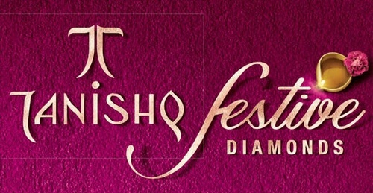

**Tanishq iPricing iStrategy:**

Tanishq iis ia iluxury ibrand, iand ihence iall iits iproducts iare ipremiumly ipriced. iThe itarget igroup iis iwomen iof iage-group i25+, iin ithe iupper iclass iand iupper imiddle iclass isection. iTanishq ioffers iexclusive idesigns, iwhich iare iboth iavailable iin itrendy iand itraditional iforms. iWith ithis ivalue iproposition, iTanishq icharges ia iprice ihigher ithan ithe ilocal ijewelers, iwho iare iits imajor icompetitors. iThe iuniqueness iof iproducts, ithe iexperience iof iTanishq istores, iand ivaried iavailability iof ichoices iallow iit ito ifollow ia iprice iskimming istrategy iin iits imarketing imix. iHigh-end, iproducts iof ihighest iquality iand iethnicity, imakes iTanishq ia ipremium ibrand. iThe ibrand ienjoys ian iassociation iwith iprestige iand istatus iin ithe isociety, ihence iit ifollows ipremium ipricing ifor iits iproducts. iAlso, ithe itarget igroup iare ithe ipeople iwho ivalue iexceptionality iabove imoney iand imore iwilling ito ipay ihigher iprice. iTanishq ialso ioffers isome ivalue iproducts, ifor itargeting ia idifferent isegment. iThis iline’s iproduct iare isimpler iin idesigns, ialthough ipromise ithe isame iquality iand itrust.

## **Tanishq iPlace iStrategy:**

Tanishq ihas ia istrong ipresence, inot ionly iin iIndia ibut iabroad. iWhen iTanishq istarted, imany iother iplayers iwere ialready ipresent iin ithe imarket iand iso iit ifocused ion ithe iinternational iwaters iof iAmerican iand iEuropean imarkets. iSlowly iits ipopularity iallowed iit ito iexpand iin idomestic imarkets ias iwell. iTanishq ijewelries iare isold iin iself-branded istores. iTanishq istores iwere istarted iat ifirst iin iChennai, ias iTitan iwas iassociated iwith iTamil iIndustrial iCo. iThe iproduction icentres iare iboth iin iSouthern iregion iHosur, iTamil iNadu iand inorthern iregion iDehradun iand iPantnagar, iUttrakhand. iTanishq ioutlet iexpansions iare ihuge, iwith inew ioutlets icoming ievery iyear. iTanishq ihas i170+ ishowrooms iin ithe ipopulated iurban imarkets. iThe istores iare ihandled iby iprofessional iexperts, iwho ieven iprovide isuggestions. iTanishq’s ionline iwebsite idisplays ithe iproducts iand imentions ithe iqualities iand idesigns ivery iprecisely ito iease iit ifor ithe icustomers ibuying ionline. iVarious idiscounts iare ialso iavailable, iwith ilarger ivariety iof iproducts, ion ithe iwebsite. iTanishq iproducts iare iexported ito iUS, iUK iand iUAE imarkets.

## **Tanishq iPromotion iStrategy:**

Tanishq icaptures ithe iattention ithrough ibeautiful iad icampaigns, imostly isurrounded iaround iIndian iweddings, iand ibeautiful ibrides. iThe iads iare ishown iboth ion iTelevision iand ionline imedia ilike iYoutube iand iFacebook. iThe ibrand ipromotes iits ijewelries ithough imovie iand iTV ichannels, iassociating itheir icollection iaround ithese imovies. iTanishq ihas iassociated iitself iwith iIndian imovies ilike iJodha iAkbar, iPadmavati ietc. iTanishq ialso iboasts iits ionline ipresence, iin iblogs, itweets iand iYoutube icommercials, ito igather ithe iattention iof igrowing itech isavvy ipopulation. iDiscounts iaround ithe iwedding iseasons iare ianother ipromotional istrategy ito ilure ithe iconsumers. iTanishq ibrands iits iself ias ia ibrand iof iPrestige iand iTrust. iFamous ifemale icelebrities ihave iendorsed iTanishq iproducts ifrom itime ito itime. iTanishq iuses icelebrity ibrand iambassadors ifor iits idiverse iproduct irange. iTanishq ialso ihas iassociated iwith icompanies iin ithe ipast, iwhich ioffered igifts ito itheir iemployees. iMaruti iis ione isuch iexample. iAlso, ithe iads itry ito icreate ia iposition iof iTanishq ias ithe ibest igifting ioption ifor ithe ibrides, ito ioffer itrust, itradition iand ibeauty. iHence ithis iconcludes ithe iTanishq imarketing imix.

Tanishq ihas ibecome ione iof ithe imajor ibrands iof iits iparent icompany iand ithis ihas ibeen ipossible ibecause iof iits i[intensive](https://www.marketing91.com/intensive-distribution/) imarketing ipolicy. iThe ibrand ihas ishot isome ibeautiful iad icampaigns ithat idisplay iits iproducts iat ia imaximum iadvantage iand igain ithem igreat ibrand iexposure. iAds ihave ibeen ilaunched ivia ielectronic imedia ion itelevision iand iradio, iprint imedia iin inewspapers, imagazines iand ibillboards iand isocial imedia iplatforms iin i[Twitter](https://www.marketing91.com/marketing-mix-twitter/), i[YouTube](https://www.marketing91.com/marketing-mix-youtube/) iand i[Facebook](https://www.marketing91.com/marketing-strategy-facebook/).

Tanishq iis iaware iof ithe iimpact iof istar ipower iand ihas iroped iin iIndian iactor iDeepika iPadukone ias iits i[brand iambassador](https://www.marketing91.com/brand-ambassador/). iShe iwill ifeature iin ivarious icommercials ito icreate ipositive i[brand iawareness](https://www.marketing91.com/brand-awareness/). iTanishq ishowroom iappeared iin iHindi imovie iRace ias ipart iof iits ipromotional iplan. iThe icompany ihas idesigned ijewellery ifor iHindi imovies ilike iPaheli iand iJodha iAkbar. iTanishq iin ithe iyear i1999 idelivered i20 icrore irupees iworth iof igold icoins ito i[Maruti](https://www.marketing91.com/swot-analysis-maruti-suzuki/) iUdyog iLimited ias igifts ito ibuyers iof iMaruti icars. iIt ihad ia ipositive iimpact ion isales iof iboth icompanies.

**SEGMENTATION**

**Niche iMarketing**

iAfter iits iinception iin i1995 ifocus ion iexports, iTanishqs idesigns ihad ibeen iTanishq ipositioned iitself ias ian iinternational ibrand ifor ithe iIndian ielite. iThe ibrand iwas itargeted iat iconceptualized ifor ithe iWestern imarkets iand iwere iintroduced iin iIndia iwithout iany ialterations. ia iniche imarket i(However ithey ilater ion istarted itargeting ithe imass imarketing isince i1997).

**Psychographic iSegmentation**

Life iStyle: iTanishq ihas ifound ithat i40% iof ithe iIndian iwomen iare iworking iand ithey itargeted ithis isegment iwith ia ispecific igroup iof iproducts icalled icollection- iG, ia i9-to-5 ijewellery ifor ithe iworking iwomen.

**Geographical iSegmentation**

Titan irealized ithat, igiven ithe idiverse inature iof iIndian iethnicity, iit iwould ihave ito isatisfy ithe itastes iof iall iregions. iSo, ithe idesigns ibecame imore iethnic. iTitan ialso idecided ito itranspose idesigns iby istocking iBengali idesigns iin iDelhi, iKeralite idesigns iin iTamil iNadu iand itypical idesigns ifrom iTamil iNadu iin iBombay iin iorder ito iappeal ito ia ivariety iof ipeople.

# SWOT ianalysis iof iTanishq

# [Tanishq](https://www.marketing91.com/marketing-mix-tanishq/) iis ia ijewelry i[brand](https://www.marketing91.com/what-is-a-brand/) iin iIndia. iIt iis ia idivision iof i[Titan](https://www.marketing91.com/marketing-mix-titan-industries/) iCompany, ia icompany ipromoted iby ithe i[Tata](https://www.marketing91.com/swot-tata-motors/) iGroup iin icollaboration iwith ithe iTamil iNadu iIndustrial i[Development](https://www.marketing91.com/customer-development/) iCorporation i(TIDCO). iTanishq’s iheadquarters iis iat iBengaluru i(Bangalore) iin iKarnataka. iHere iis ithe i[SWOT](https://www.marketing91.com/swot-analysis-brands/) iAnalysis iof iTanishq.

## **Strengths iin ithe iSWOT ianalysis iof iTanishq i:**

1) i**The ibacking iof iTata, iTitan iand iTN igovernment i– i**Tanishq ihas ia istrong ibacking iof iTata iGroup iand iTN igovernment igiving iit ithe inecessary iresources iand i[markets](https://www.marketing91.com/types-of-market/) ito ifunction iwell.

2) i**A itrusted ijewelry ibrand iin iIndia i– i**It ihas ibeen ione iof ithe imost itrusted ijewelry ibrands iin iIndia iwhich i[brand irecall](https://www.marketing91.com/brand-recall/) iis ivery ihigh. iThis igives iTanishq ian iedge iover iits icompetitors.

3) i**Excellent ipromotional iactivities i– i**There ihave ibeen ia ilot iof i[advertising](https://www.marketing91.com/what-is-advertising/) iand i[promotions](https://www.marketing91.com/promotions-in-marketing/) ifor ithe ibrand iin iterms iof iTV iads, ihoarding, ipromotional ioffers. iAgain ithis iis ihelping iin imaintaining ithe ibrand ivalue iof iTanishq iin ithe i[market](https://www.marketing91.com/market/).

4) i**Right i**[**Product**](https://www.marketing91.com/what-is-a-product/) **iMix i– i**Tanishq inot ionly ihas iwedding iand idiamond icollections ibut ialso ideals iin isimple, ilow-priced, idaily iwear ijewelry i[products](https://www.marketing91.com/types-of-products/) igiving iit ian i[opportunity](https://www.marketing91.com/opportunity-analysis/) ito ireach iout ito ithe icustomers iof ievery istratum iof ithe isociety.

5) i**Widespread igeographical ipresence i– i**Tanishq ihas ia istore ipresence iin imore ithan i100 icities iin iIndia. iThis iis ihuge ifeat ibeing ia ijewelry ibrand iand iit iagain igives ian iedge iover imost iof ithe icompetitors isince ia iproduct ilike ijewelry iis iwhat i[people](https://www.marketing91.com/people-marketing-mix/) iwant ito ifeel iand ibuy.

6) i**Multiple iaward-winning ibrands i– i**The ibrand ihas iwon imany iawards iin ithe ipast ifor iits idesigns, imarketing, iand iretail ichain icategories ito ifurther istrengthen iits ibrand ivalue.

7) i**Endorsement iby ifamous i**[**celebrities**](https://www.marketing91.com/celebrity-endorsement/) **i–**Amitabh iBachchan, iJaya iBachchan, iDeepika iPadukone iand imuch imore iare ithe ilikes iof icelebrities ithis ibrand ihas igot iit iassociated iwith ifor iendorsement. iThese icelebrities ihave ian ievery ihousehold ireach iin iIndia iwhich istrengthens ithe i[brand iassociation](https://www.marketing91.com/brand-association/) iof ipeople iof idifferent icategories iwith iTanishq.

## **Weaknesses iin ithe iSWOT ianalysis iof iTanishq**

1) i**Limited i**[**international**](https://www.marketing91.com/international-marketing/) **ipresence i– i**Tanishq ihas ia ivery ilimited iinternational ipresence ias icompared ito isome iof ithe iinternational ibrands iin ithe ijewelry iarena.

2) i**The ilimited iscope iof igrowth idue ito ifierce icompetition i– i**A ilarge inumber iof iregionalized icompetitors iin iIndia idoes inot iallow ia ifast-paced igrowth iin ithe imarket. iTanishq ihas istores iin imore ithan i100 icities ibut ithe igrowth irate iis inot ias iexpected idue ito ithese i[direct icompetitors](https://www.marketing91.com/analyse-defeat-direct-competition/).

3) i**Initial inegative iperception iof ithe ibrand ibeing ifor irich ionly i– i**The iearlier iperception ithat iTanishq icaters ionly ito ithe irich ipeople ihurts ia ilittle. iEven ithough ithey ihave iproducts ifor ilow-income igroups ias iwell inow, ithis inegative iperception i[needs](https://www.marketing91.com/needs-wants-and-demands/) ito ibe iremoved icompletely.

## **Opportunities ifor ithe iSWOT ianalysis iof iTanishq**

1) i**Expand iglobally i– i**This iis ia ihuge iopportunity ifor iTanishq iwhich iwill ihelp iin iincreasing ithe ireach, irevenues, iand iprofits iif ithey ican isuccessfully iexpand ithemselves iglobally.

2) i**Improve igrowth irate iand i**[**profitability**](https://www.marketing91.com/customer-profitablity-analysis-2/) **i– i**This iis inecessary ifor ievery icompany iin ievery iindustry ibut iyes ifor iTanishq iit ibecomes iall ithe imore iimportant ito imake isure ithey iare iprofitable iin ithis ivolatile imarket iwith isuch idynamics iand icompetition.

3) i**Tap ithe igrowing ieconomy i– i**It iis iimportant ito iunderstand ithe igrowing i[demands](https://www.marketing91.com/types-of-demand-2/) iof igrowing ieconomy iand ilaunch ithe iright iproducts iat ithe iright itime. iThis iis iwhere iTanishq ireally ifocuses iupon ito iincrease itheir i[market ishare](https://www.marketing91.com/market-share-definition/).

4) i**Indian iwedding imarket iis ia ibig iopportunity i– i**Indian iwedding imarket iis ione iof ithe ibiggest iareas iwhere ievery ijewelry icompany ican isee isomething ifor iitself iand iTanishq iis ino idifferent. iThis imakes iit isignificant ito icontinuously ikeep ithis imarket iinterested iin ithe ibrand. i

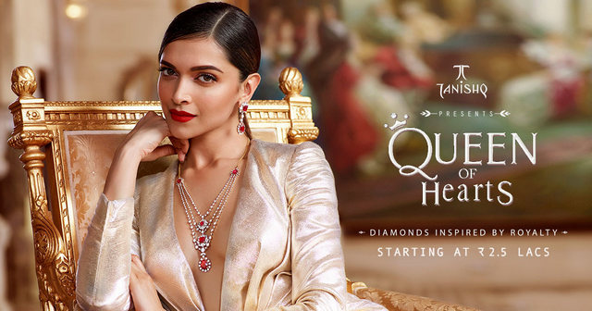

## **Threats iin ithe iSWOT ianalysis iof iTanishq**

1) i**Escalating igold irates i– i**Gold irates iare ian iever-escalating iaffair iwhich imakes iit idifficult ifor ia icompany ilike iTanishq ito ihave ithe iconsistent i[profit imargins](https://www.marketing91.com/how-to-calculate-profit-margin/).

2) i**Dynamic** if**ashion itrends i– i**Fashion itrends iare ialways iin ia ichange imode iwhich ineeds ito ibe imet ion ialmost idaily ibasis. iThis iaffects ithe imonetary ivalue iof ithe iinventory iof isuch ia ibig iorganization.

3) i**Strong icompetition ifrom iboth ibranded iand itraditional ijewelers i– i**Competitors iare ialways ia ithreat ito ieveryone iis iexpanding iwhich imakes ithe iwindow iof igrowth ieven ismaller.

4) i**Gold iis inot iseen ias ian iinvestment ianymore i– i**A ibig ipopulation iin iIndia iwhich iused ito ibuy ijewelry iby iconsidering iit ias ian iinvestment iis inow imoving ito idifferent ioptions ito iinvest. iIt imakes ithe iindustry imore idependent ion iluxury iand ifashion i[targets](https://www.marketing91.com/swot-analysis-target/).

5) i**Changes iin igovernment ipolicies iand itaxes i– i**This ihas ibeen ia ibig iproblem ifor iluxury iitems. iEvery ibudget isees ichange iin isome iof ithe iother iway iin iluxury iproducts ilike ijewelry iwhich iaffects ithe iprofitability iof isuch icompanies iin ia ibig iway.

6) i**Increasing irates iof iinterest i– i**This iis iagain irelated ito ithe ichanges iin ifinancing irates iwhich iare iincreasing iyear ion iyear imaking iit imore idifficult ito ireach iprofitability iconsistently.

**MOBILE MARKETING STRATEGIES and MOBILE CHANNELS :**

*Mobile marketing is the sharing of a brand or business in a way that is optimized for smartphones and other mobile devices throughout apps, social media channels, and websites.*

According to SiriusDecisions, 67% of the buying process now takes place digitally.

From a business perspective, it’s important to realize that the way in which their customers are consuming digital content has changed from desktop-based to mobile-based. In 2015, mobile use surpassed desktop use, with 51% of internet time being spent on mobile and smartphone devices.

Now let’s dive into the strategies which can we useful in terms of Marketing strategies:

1. Advertisement for specific Mobile device through Google AdWords.
2. Must launch mobile apps and responsive websites.
3. Universal Campaign
4. Location Based marketing
5. Social Media Advertisement
6. Mobile friendly content
7. Text-messaging marketing
8. Voice search optimization

**Advertisement for specific Mobile device through Google AdWords.**

Tanishq the jewellery brand from the house of Tata (turnover of Tanishq expected to be about Rs.10000 crores for the current fiscal) has been heavily trending on social media after it launched the latest television commercial.

Google AdWords enables advertisers so that they can start campaign for targeting specific mobile devices. They can advertise for specific mobile platform and devices.

Also, CPC is increasing for mobile users in comparison of desktop users. Combination of two facts i.e. increasing CPC and mobile uses leads to high ROI.

**Must launch mobile apps and responsive websites.**

Mobile app is also an effective way to approach user with a friendly environment. Increasing use of Smartphone increases app usage and its popularity among users.

**Universal Campaign**

In the history of Tanishq advertisement. There are many campaign involves which helps to increase the revenue of the company.

Tanishq has been very active about campaigning and promoting their products.

**‘#HeeronMeinHeera’ campaign:**

It was educated and creative in nature. With this campaign, Tanishq wanted the customer to set some pointers before buying any diamond jewellery. For promoting its sub-brand Mia, Tanishq made an ad campaign named ‘best at work’ as this sub-brand was launched for the working women.

Link:

https://youtu.be/gXezPfCw5JY

**‘#WomenofGold’ campaign:**

Many famous celebrities like Amitabh and Jaya Bachchan and Deepika Padukone have appeared in some Tanishq advertisements.

the brand wanted to inspire women to achieve their dreams by breaking all the stereotypes and challenging every societal norm.

Link: https://youtu.be/VjY5p1RjKWU

**Location Based marketing:**

location-based marketing techniques like geofencing to market to mobile users in a specific area.

Over 80% of marketers say location-based marketing leads to increases in three key metrics: an 85% increase in customer base, an 83% increase in response rates, and an 83% increase in customer engagement.

**Social Media Advertisement & mobile friendly content:**

The jewellery brand didn’t need to try harder. The beauty and glamour of its product has pulled people like ants to a block of sugar. And this explains the number of fans it has on the page, which, at the time of writing, was more than 484,000. But because it lacks an appropriate strategy for customer engagement, the level is ever wavering,

There some analysis buget basis so that we can eslimate overall performance of the company

**Text messaging marketing and Voice search:**

A successful text message campaign starts with giving people the chance to opt in to future messages. Three-quarters of people have no problem receiving SMS messages from companies they love, and 90% of people read those messages within three minutes of receiving them. That means text messages have astronomical open rates—people read almost 100% of text messages.

Around the world, over half of all households should own a voice-enabled device by 2022, an increase of 42% over the current ownership numbers. Of the people who don’t own a voice-enabled device, 34% of them have some interest in owning one.

Analysis in Terms of **Mobile channels**.

1. Youtube channel
2. Facebook page
3. Twitter account
4. Various giant e commerce tieups
5. SMS marketing, email marketing, SEO

Tanishq have multiple Mobile channels which can helpful for the promotion and Tarket the market for the better revenue.

Tanishq have an active youtube channel with some very good content pieces, and it has also registered its presence on Pinterest where it shares its products on various boards..

There are many good deals available on the Paytm, Freecharge and many other e commerce platform that creates a messive impact on the growth of the company

**Conclusion:**

After its inception in 1994, Tanishq had to struggle at first in the market. But the strong and determined attitude of the members of the brand has made them successful. They have always cared for their customers and provided them products with prime quality at an affordable price.

Because of this attitude, Tanishq is also getting success in the other countries which will help the brand to gain more confidence and release more products with innovative designs.

**Reference:**

* Textbooks
* Youtube
* Wikipedia
* Some research papers
* Some advertisement